Greenline Passenger

By Redstone

# Table of contents

Contents

Table of contents 2

Research 3

Audience 3

# Research

## Audience

Our audience are as followed: Business related individuals, Students, Families and couples. Our age target is between from 16 and onwards. We provide services for all genders and backgrounds. Our main goal is to make our customers feel easy to use our system to get to their destination by giving them excellent ticket prices.

## Personas

## Competitors

### Opodo

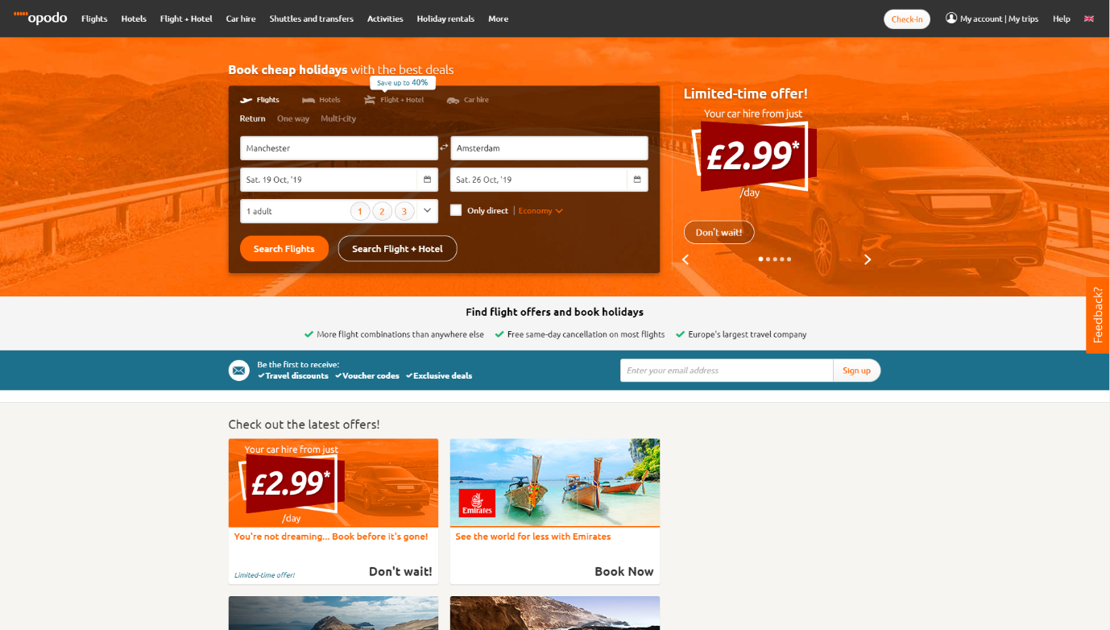

URL Link: [https://www.opodo.co.uk](https://www.opodo.co.uk/)